Start of the project :

Prompt :

|  |
| --- |
| "template": "bolt-vite-react-ts", use only "lucide-react" for icons, "react-hot-toast" for notification,  "typescript-eslint" and "autofixer" for defect troubleshooting and fixing.  Create an app to add course, view the course in cards. Course details - Title, Description, Course image,fees, and option to add chapters and videos under chapter. |

Outcome :

Here's a concise summary of the menu items and their current status:

**Working Pages:**

* **Dashboard**: Displays course statistics and recent courses. It is fully functional and not just mock out for the courses. Total stuendents, Total revenue were mock data just for reference.
* **Courses**: Lists all available courses.
* **Add Course**: Allows creation of new courses with chapters and videos.
* **Course Detail**: Shows details for a specific course, including a video player.

**Known pending work:**

**Videos**: Not actual video addition but just link to video. Videos not visible in the course details.

* **Students**: Currently shows a "Students management coming soon..." message.
* **Settings**: Currently shows a "Settings panel coming soon..." message.

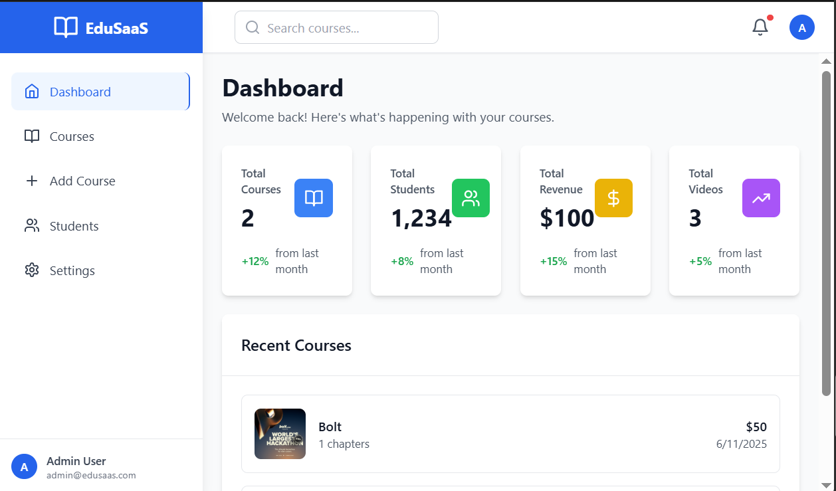

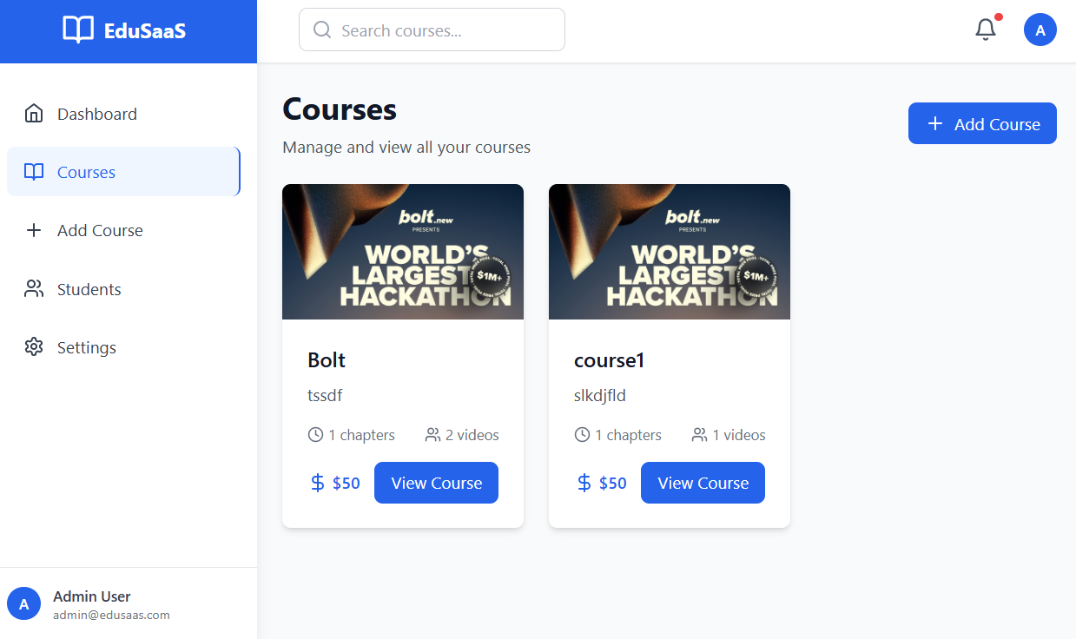

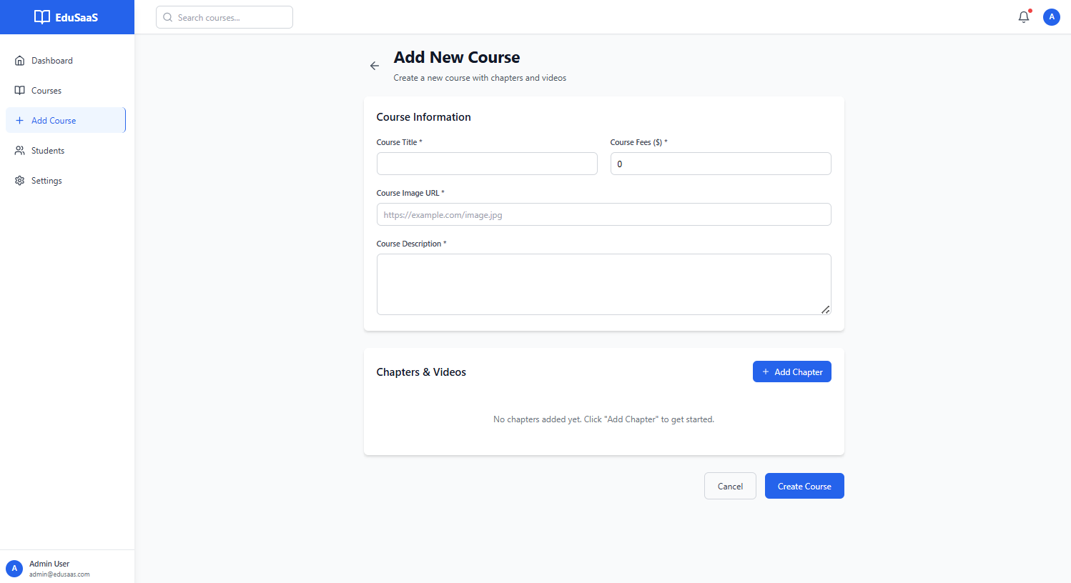

Learnings:

|  |
| --- |
| Making clear stack selection requirements. This helps to not use multiple source for similar functionality and gives optimized code with lesser dependencies and libraries used.  Prompt : be specific for fields that you wanted to have in your system e.g. courses could have multiple things, say clearly what fields you are expecting. |

2. Integrate external database supabase:

Prompt:

|  |
| --- |
| Move the project to supabase database. |

Second prompt :

|  |
| --- |
| Implement course deletion functionality. |
|  |
|  |

Third Prompt:

This time I have to also start cleaning up the code for responsiveness. So added it into prompt. And to optimize token usage informed : *age that you are updating ensure that it is responsive. dont check page responsive for all page, only those getting changed. Add tag "PageResponsiveChecked" so that next time you dont check responsivity of that page*

|  |
| --- |
| page that you are updating ensure that it is responsive. dont check page responsive for all page, only those getting changed. Add tag "PageResponsiveChecked" so that next time you dont check responsivity of that page. Bug : There is no UX available to upload video in Addcourse or Editcourse.  **Bolt** |
|  |

Output :

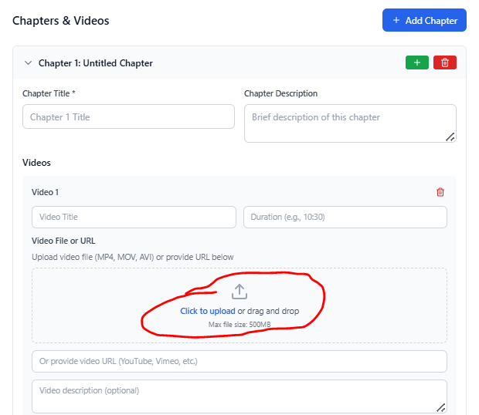

Auto Detection of the bug by bolt:

*I can see the issue - the Supabase Storage buckets that the application is trying to use don't exist yet. The storage service is attempting to upload files to buckets named 'course-images', 'course-materials', and 'course-videos', but these haven't been created in your Supabase project.*

*Bolt asks for confirmation to execute command to supabase server and it automatically completes integration.*

3. Adding registration and landing page.

5. Adding Student Enrollment for the course.

|  |
| --- |
| if couses is enrolled, Coursecard will get 'Enrolled' for the user. Update CourseCard.tsx for button to allow enrolling the course. For enrolled course, clicking on View Course button will show CourseEnrollDetail.tsx. Add route for CourseEntrollDetail.tsx. Dont give me explanation, just brief update after change. |

I have manually copied CourseEnrollDetail.tsx. (I don’t know why I have done it, may be just wanted to keep the design intact with CourseDetail which is currently implemented)

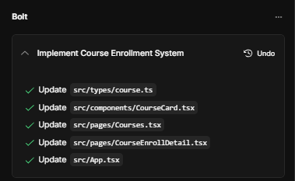

And brief update by bolt

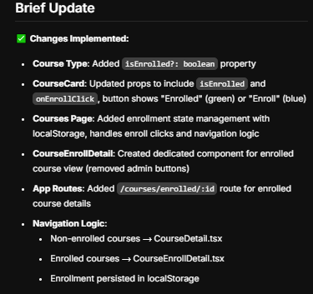

This is what we wanted to implement for the Navigation logic, for the enrollment and non-enrolled courses, and bolt did it.

However there is bug, that bolt has replaced the existing button. So another prompt :

|  |
| --- |
| Only change for Coursecard.tsx : you have replaced 'View cource' button in course card. I have asked to add the button for Enroll. so there will be two buttons on course card one for enroll functionality and another for see course details. |

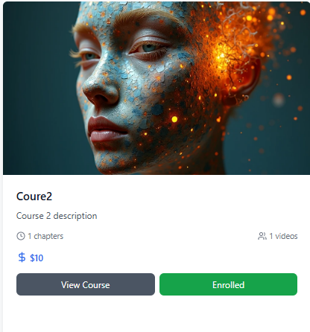

Database integration was missed, so informed

|  |
| --- |
| implement database integration for Enrollement. it should be stored against that user. |

Done the changes, but encountered issue when clicked on courses. Autodetected and Autofixed:

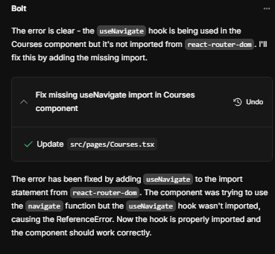

Adding the Tavus Agent:

Prompt :

|  |
| --- |
| Only change pages admin/CourseAdd.tsx, admin/CourseDetail.tsx, admin/CourseEdit.tsx and related page dependencies required for operation.  Add more details to course :   * add Topic category courses : Technology, Project Management, Finance, Sustainability. * add field 'agent_course_description' type textparagraph. * add field sponsored - yes/no * change in Chapters & Videos Section - Under chapter, user can either add video or an agent. add type of sub-task so that it can rendered correctly. No change for the video, but if agent add is selected - it will ask for additional fields 'replica id' and 'conversationalcontext'   Do not change for now user access CourseDetails.tsx and CourseEnrollDetails.tsx, that I will change afterwards. |

Some limitations of the bolt.new – it updated courses.tsx even though I have said NO.

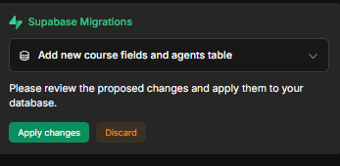

Bug: Autodetected and fixed.

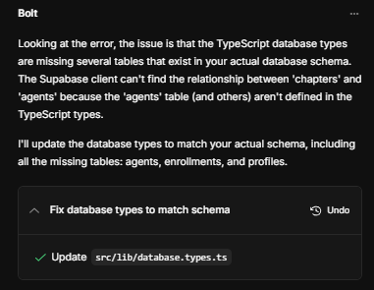

Bug – in the couse edit.

The root cause of the issue was the presence of two separate CourseEdit.tsx files in your project:

1. src/pages/admin/CourseEdit.tsx
2. src/pages/CourseEdit.tsx

So, asked bot, to rename the sr. no. 1 to ‘src/pages/admin/AdminCourseEdit.tsx’.

This has been fixed :

Now implement launching of Tavus.io agent from EnrolledCousre page.

Prompt :

|  |
| --- |
| add below functionality /home/project/src/pages/CourseEnrollDetail.tsx. Add view functionality for newly add content type agent, similiar to Admin/CourseEdit.tsx. Addition of Tavus.io agent : for agent when chat icon is clicked in sub-content, launch conversation with agent for Tavus.io. Use Replica Id provided in the task, and Conversatoinal Context field from the course sub-content respective Agent type. Use name from the user profile . UX :Show video on the same page by embedding it in the page as a tab with Coursecontent. Provide back to come again to coursecontent. At any point only show one tab. |

Bug :

Prompt

|  |
| --- |
| Got this message when trying to click on the chat on the src/pages/CourseEnrollDetail.tsx |

**Bolt**

|  |
| --- |
| In courseEnrolldetaill.tsk, when click on chat button, use tavus.io api to create conversation and launch conversation, user Replica ID and Conversational Context from the respective sub-content. |

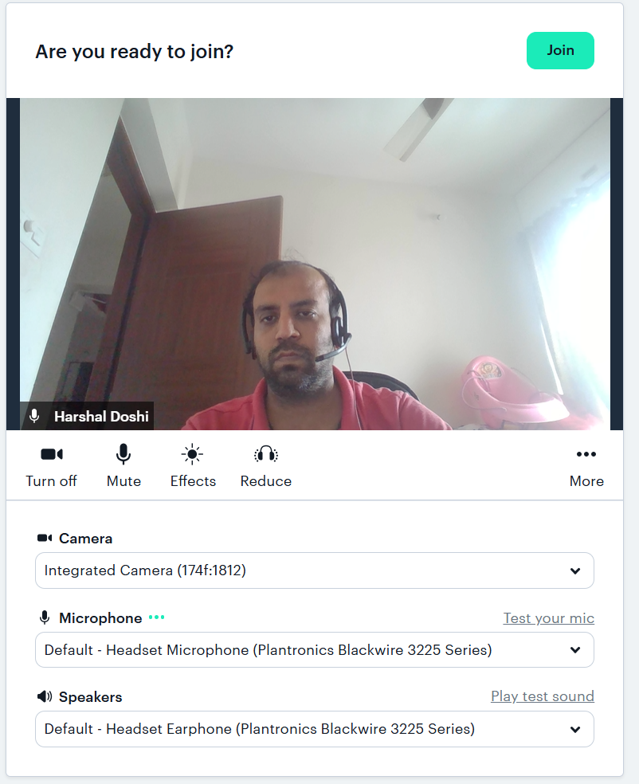

So this has been completed.

So basic things are working. Now I have created one

Changed the agent:

Agent was asking me more information about the “journey so far in the course”, which is not the case, so, it is important to add in the context.

At the Start of the conversation , say all this proactively : {{ Greet with his name, Praise him for enrolling the course, by informing reputation of the institute. and also informing that he will be getting certificate with unique id and URL}}. Course details he enrolled: This course teaches you the underlying patterns behind common coding interview questions. By learning these essential patterns, you will be able to unpack and answer any problem the right way

Has been modified to

**Student has just enrolled and you are the first person to meet.** At the Start of the conversation , say all this proactively : {{ Greet with his name, Praise him for enrolling the course, by informing reputation of the institute. and also informing that he will be getting certificate with unique id and URL}}. Course details he enrolled: This course teaches you the underlying patterns behind common coding interview questions. By learning these essential patterns, you will be able to unpack and answer any problem the right way

Prompt :

|  |
| --- |
| clear browser cache memory, as it not updateting course contents after editing. |

Bugs resolved :

I'll add cache-busting mechanisms to ensure course content updates are reflected immediately after editing, without requiring manual browser cache clearing.

|  |
| --- |
| Update only these pages - admin/AdminCoursedetail.tsx, admin/courseedit, courseenrollDetail.tsx.coursedetail.tsx,courseadd.tsx. (0) (1) Upload of Document as sub-topic similiar to video and agent under chapter. option to mark it as special document. Mark Done option required for Non-special document. (2) Knowledgebase - to show all documents of course and the sub-topic document at one place. add proper details of chapter reference wherever possible (3) Speical Downloads : This gets available for download only when chapter is complete (i.e. when all the task of that chapter is completed ). For the file that you are changing optimize it for responsive behaviour and also create seperate css file for better modification. |

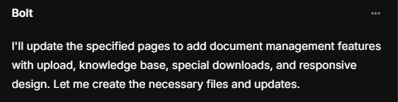

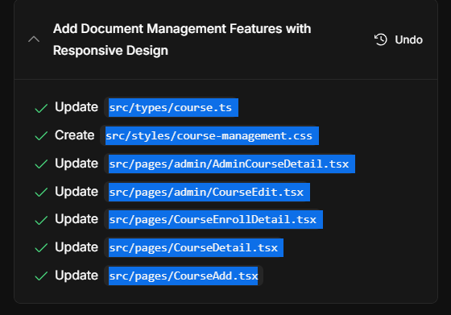

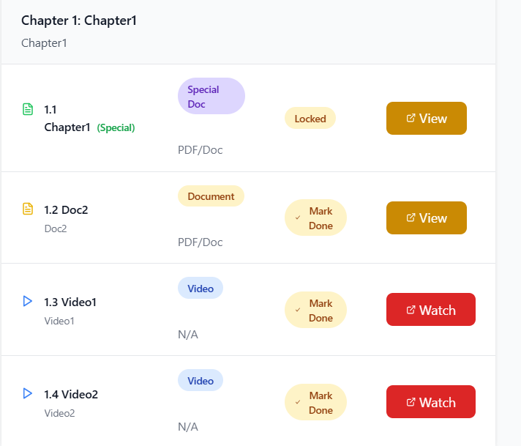

I was looking and

And I delivered it